***Lab 7- Code First Approach with Entity Framework***

*Create an Empty MVC Application.*

*Add a Product class in Model Folder:*

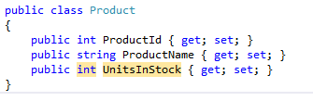

*Build the solution:*

*Add a Controller: Right click on Controllers Folder > Add > Controller*

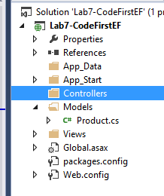

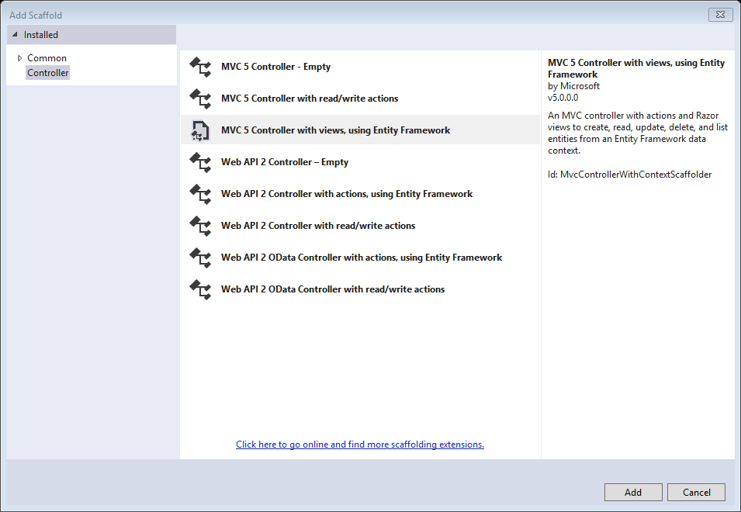

*Select MVC 5 Controller with views, using Entity Framework > Click on Add button*

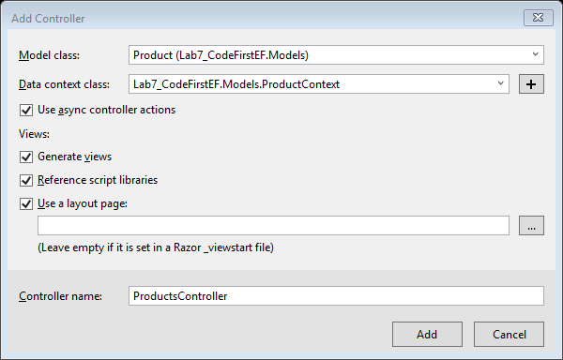

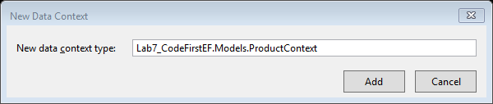

*Select the following as show in the above image: Model class = Product class > Data Context class: click on the plus sign button (New data Context) > click Add button > check the “Use async controller actions” checkbox > Controller Name = ProductsController > Click on Add button*

*Check the solution explorer:*

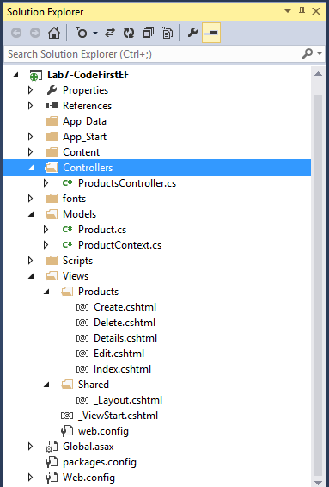

*There is no database. After you execute by entering Products/Index output will be as follows:*

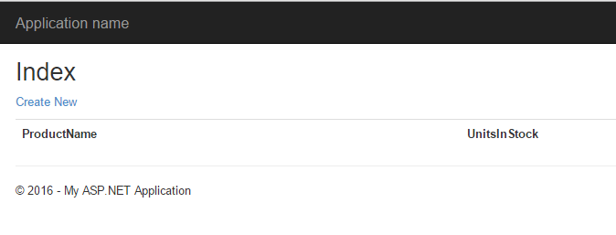

*Run the code and the database will be created.*